**CheMin**

**Software Project Document**

**Group Members**

Poonam Lakhangaonkar

Rajnish Kumar

Valentin BERTHOMIER

Hiren Patel

* **CheMin Description:**
* CheMin, short for Chemistry and Mineralogy
* CheMin is a mineralogy instrument that will identify and quantify the minerals present in rocks and soil delivered by the rover's robotic arm
* CheMin uses:
  + A technique called X-ray diffraction (XRD) for mineralogy characterization
  + X-ray fluorescence (XRF) for elemental characterization
  + A single detector for both measurements
  + One moving part (Sample wheel)
* **Code Description:**
* **How it works:**

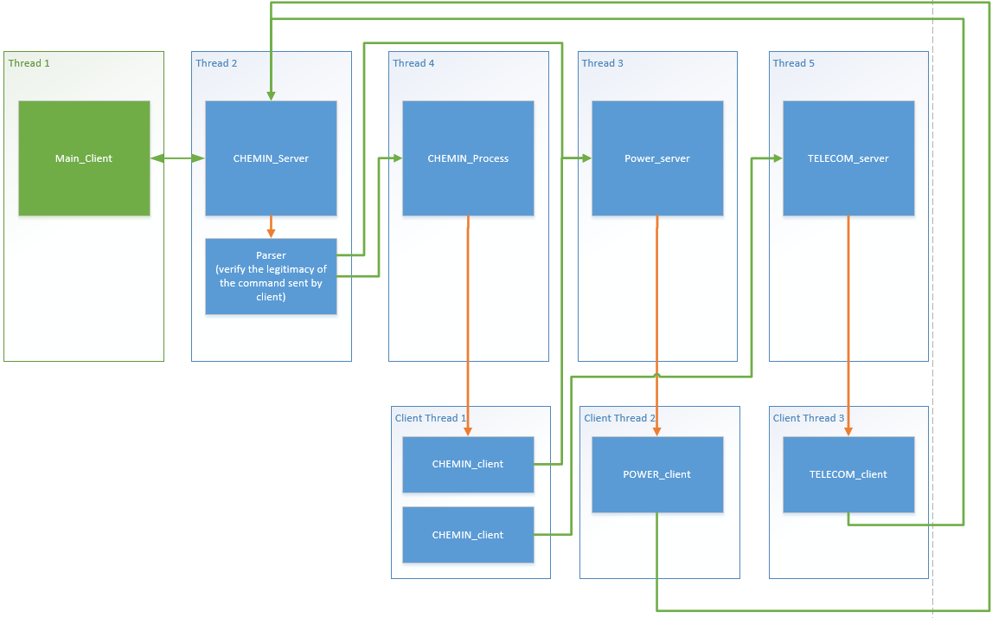

* 1. Create 3 modules and start the threads one by one for each
     1. CheMin Server and CheMin Process (CheMinModuleMain)
     2. Power Server
     3. Telecom Server
  2. CheMin Server

1. If message is  ‘chemin_on’
   * Set CCU to true and create CheminClient(9013->power) thread and start it
2. If message is ‘power on’
   * Launch chemin process create CheminClient(9002->Telecom) thread and start it
3. If message is ‘Power Off’
   * Then free Chemin threads
   1. CheMin Client
4. If port is 9013
   * PowerRequirement is sent to PowerClient
5. If port is 9002
   * XrdDiffraction image is sent to TelecomClient
   1. CheMin Process

1. f_xray_set_position()

* + set and configure x-ray beam position

2. f_sample_receive()

* + launch the powder sample receiving procedure
  + If inlet cover is opened, abort the operation

3. f_cell_go_to(5)

* + Choose the sample cell (depending on given sample cell number and current sample cell)

4. f_cell_clean_current()

* + Start the cleaning procedure

5. f_inlet_open()

* + Open inlet cover if not opened already

6. f_piezzo_tun_on(v_current_sample_cell/2)

* + Turn on the given piezzo if not on

7. f_inlet_close()

* + Close inlet cover if not closed already

8. f_piezzo_turn_off(v_current_sample_cell/2)

* + Turn off the given piezzo if not off

9. f_xray_turn_on()

* + Turn x-ray on

10. f_analysis_start()

* + Verify that every component is ready to start analysis phase
    1. X-ray position
    2. X-ray on
    3. Inlet cover closed
    4. Sample cell contamination checked
    5. Sample not contaminated
  + If all above checks satisfied then turn off piezzo
  + Starts analysis

// need to add here

11. f_cdd_create_diffraction_image()

* + Create diffraction image

12. f_cdd_create_1d_2t_plot()

* + Create 1D 2theta plot image

13. f_send_results()

* + End of process, send results to telecom
  1. Power Server

1. Waits for client message

2. If receive message, print it

* + then create power client(9008->CheminServer) thread and start it
  1. Power Client

1. Print socket port

2. If socket port is 9008

* + then  send "POWER ON" to port 9008 (to Chemin Server)
  1. Telecom Server

1. Waits for client message

2. If receive message print it

* + then create telecom client(9008->CheminServer) thread and start it
  1. Telecom Client

1. Print socket port

2. If socket port is 9008

* + then  send "Chemin receives telecom acknowledge" to port 9008 (to Chemin Server)

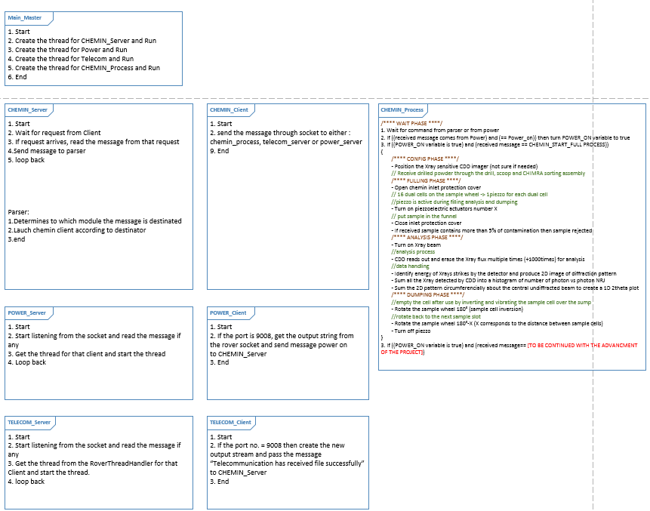

* **How to run it:**

1. Download / Clone this project in Eclipse.
2. Build this project.
3. Remove any libraries problem. You have to use only two libraries and these two libraries are included in this project.
4. Use latest Java version 1.8 because ‘Javafx’ functionality has been included in this project.
5. 1) If want to run the **test program with the rover simulator**: Under ‘src’ -> ‘test_main’ package -> run ‘TestMain.jar’

2) If want to run **the chemin program without the rover simulator**: simulator: Under ‘src’ -> ‘main’ package -> run ‘SimulateRoverMain.jar’

1. CheMin will start working

* **List of commands:**
* ***//xray beam***
* f_xray_set_position();
* f_xray_turn_on();
* ***//sample , sample cell sample wheel***
* f_sample_receive();
* f_cell_next();
* f_cell_go_to(cell_number);
* f_cell_clean_current();
* f_cell_empty_current();
* f_fill_sample_cell();
* ***//inlet protection cover***
* f_inlet_open();
* f_inlet_close();
* ***//piezzo***
* f_piezzo_tun_on(piezzo_number);
* f_piezzo_turn_off(piezzo_number);
* f_analysis_start();
* ***//results***
* f_cdd_read_erase(); //1000times in analysis
* f_cdd_create_diffraction_image();
* f_cdd_create_1d_2t_plot();
* f_send_results();
* power_off() ;